

**ASSIGNMENT ON STRING FUNCTION**

***Programming in C***



January 16, 2022

*SUMMITTED by Alan varghese*

**STRING**

In C programming, a string is **a sequence of characters terminated with a null character \0** . For example: char c[] = "c string"; When the compiler encounters a sequence of characters enclosed in the double quotation marks, it appends a null character \0 at the end by default.

STRING HANDLING FUNCTIONS

**1.strcat()**

*It is used to concatenate two string.*

*Eg:program to concatenate two strings.*

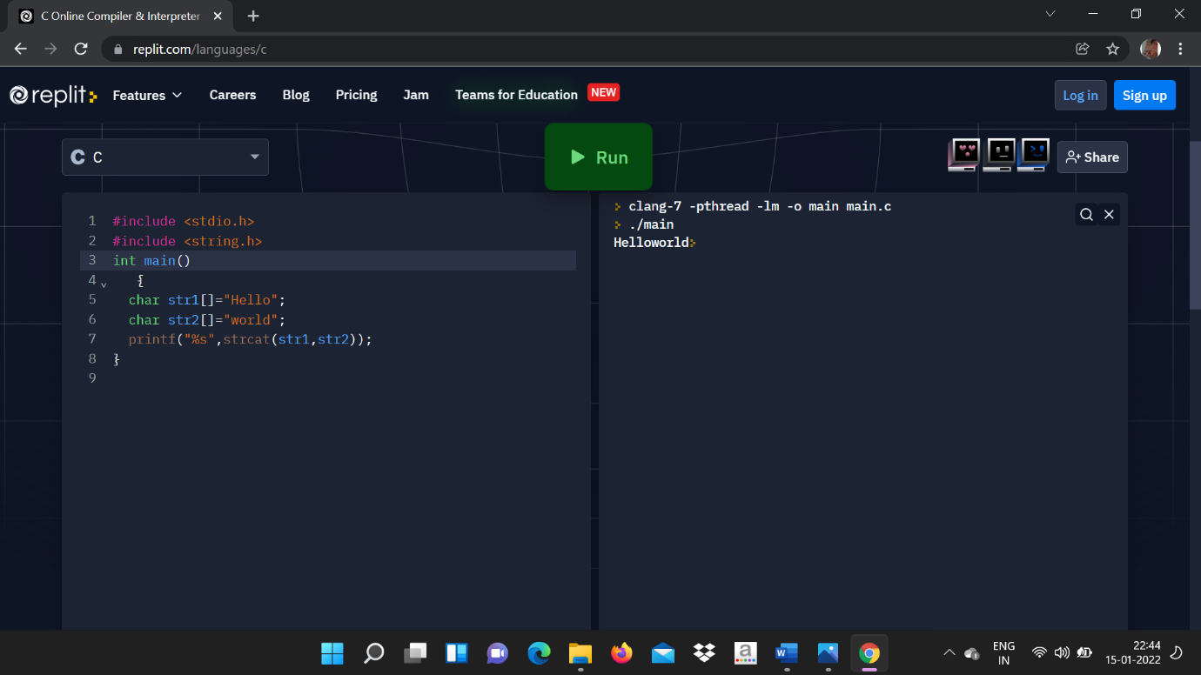

o/p

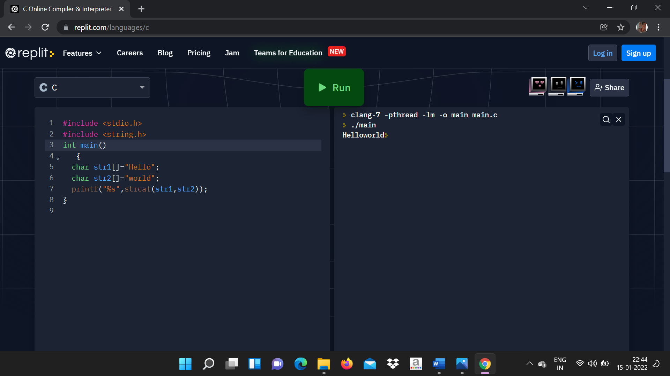

2.strlen()

*It is used to show the length.*

*Eg:program to find the length of the string.*

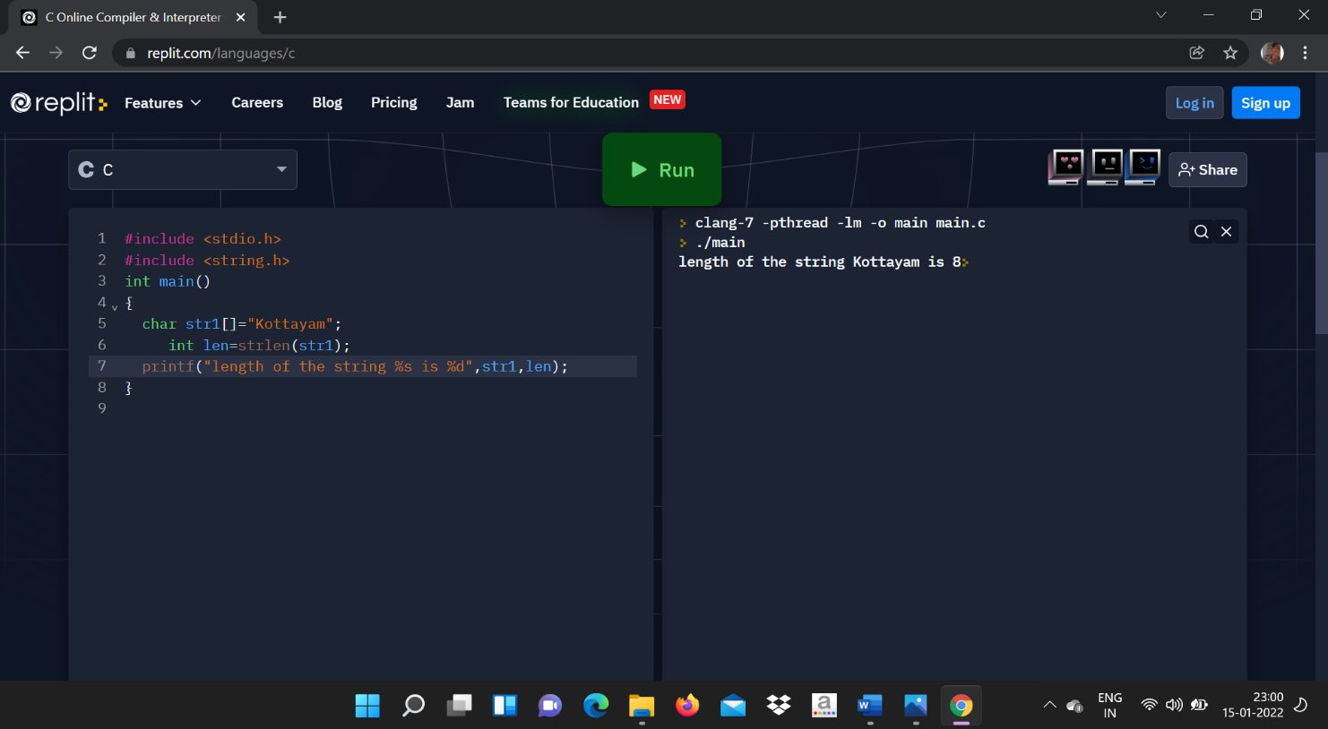[1]

o/p

1. 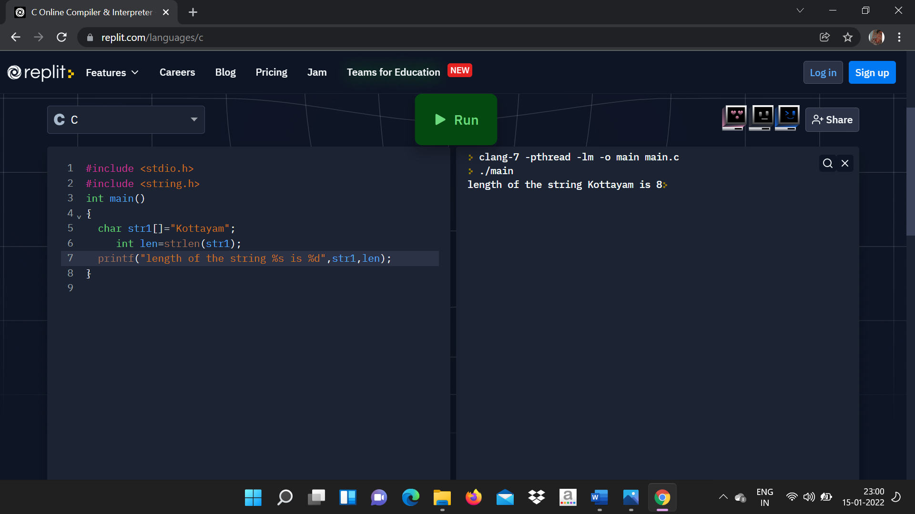

   **3.strcmp()**

   ***It is used to compare two strings*.**

   *Eg:program to compare two strings.*

   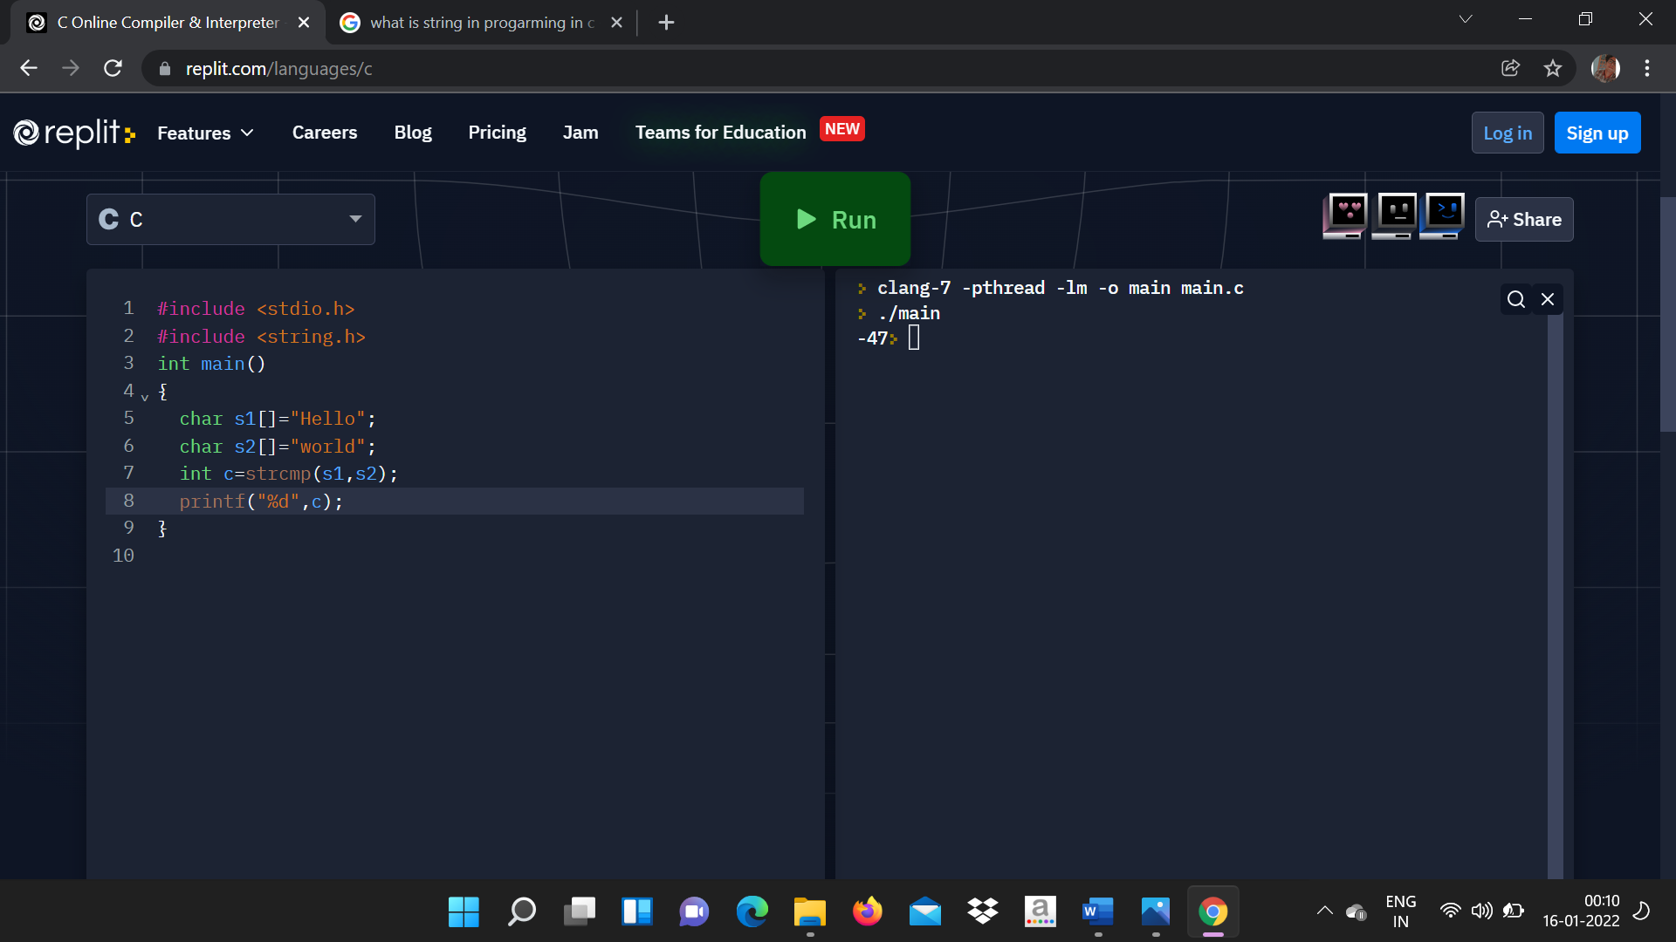

   o/p

   

   4.strrev()

   **It is used to show the reverse of the string.**

   *Eg:program to print the reverse a string.*

   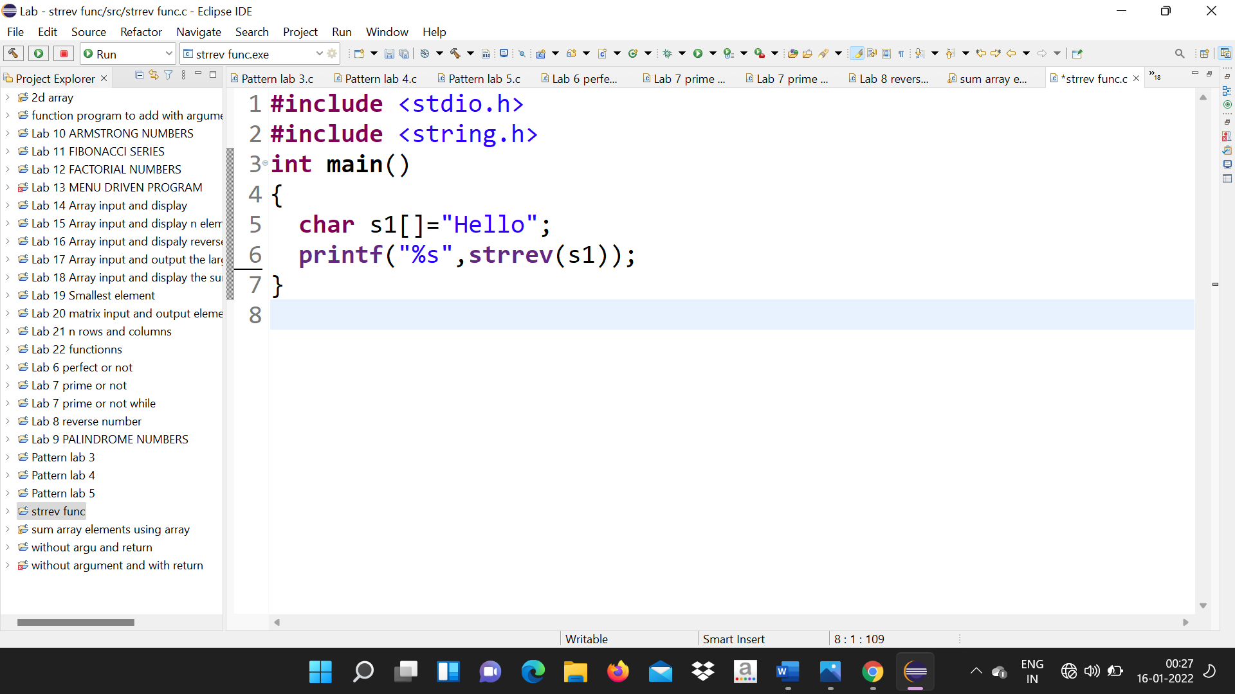

   o\p

   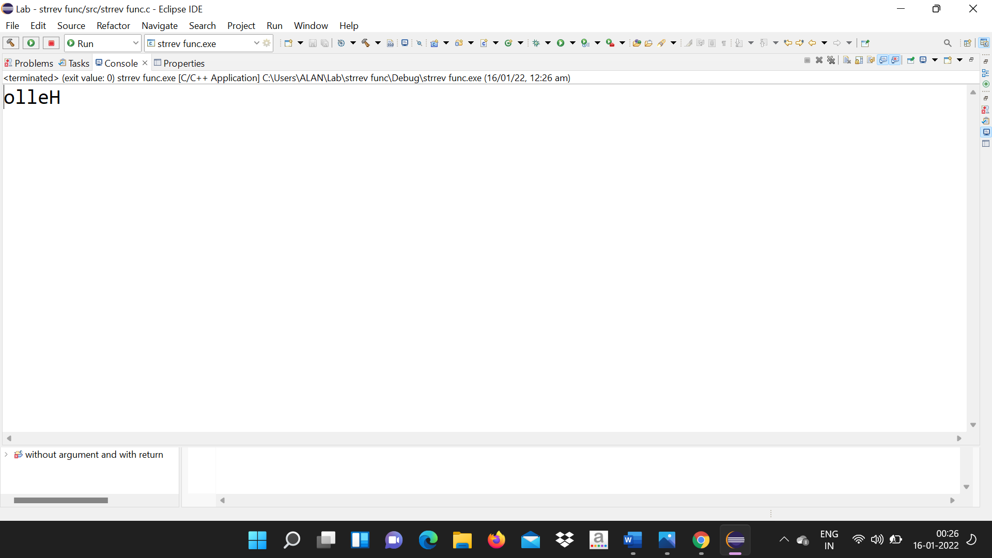

   5.strcpy

   *It is used to copies one string to another.*

   *Eg:program to copy one string to another and print it.*

   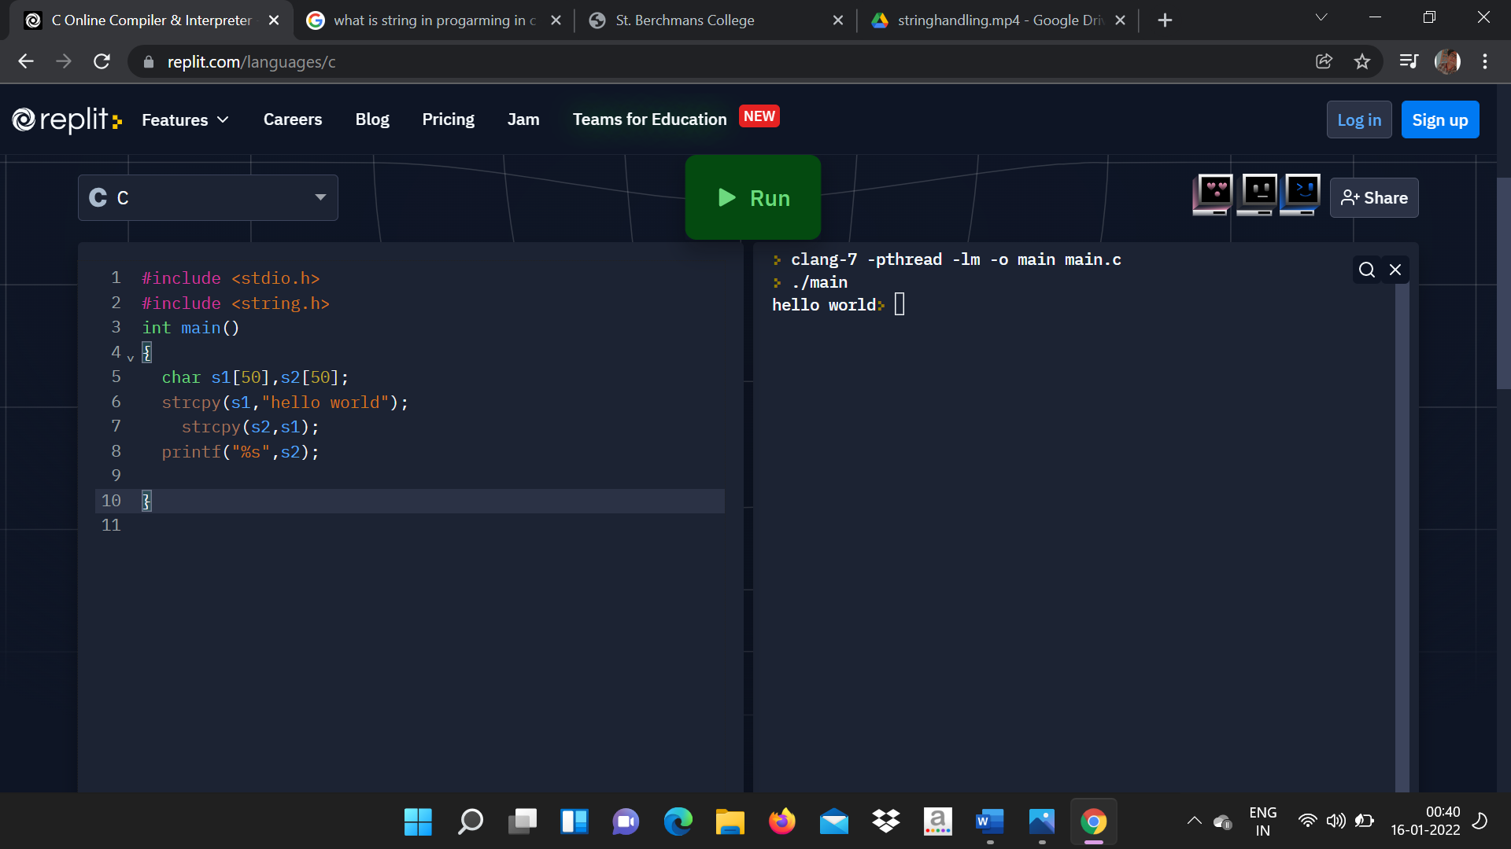

   o\p

   

   6.strlwr()

   ***It is used to covert the input to lowercase.***

   *Eg:program to convert the string to lowercase.*

   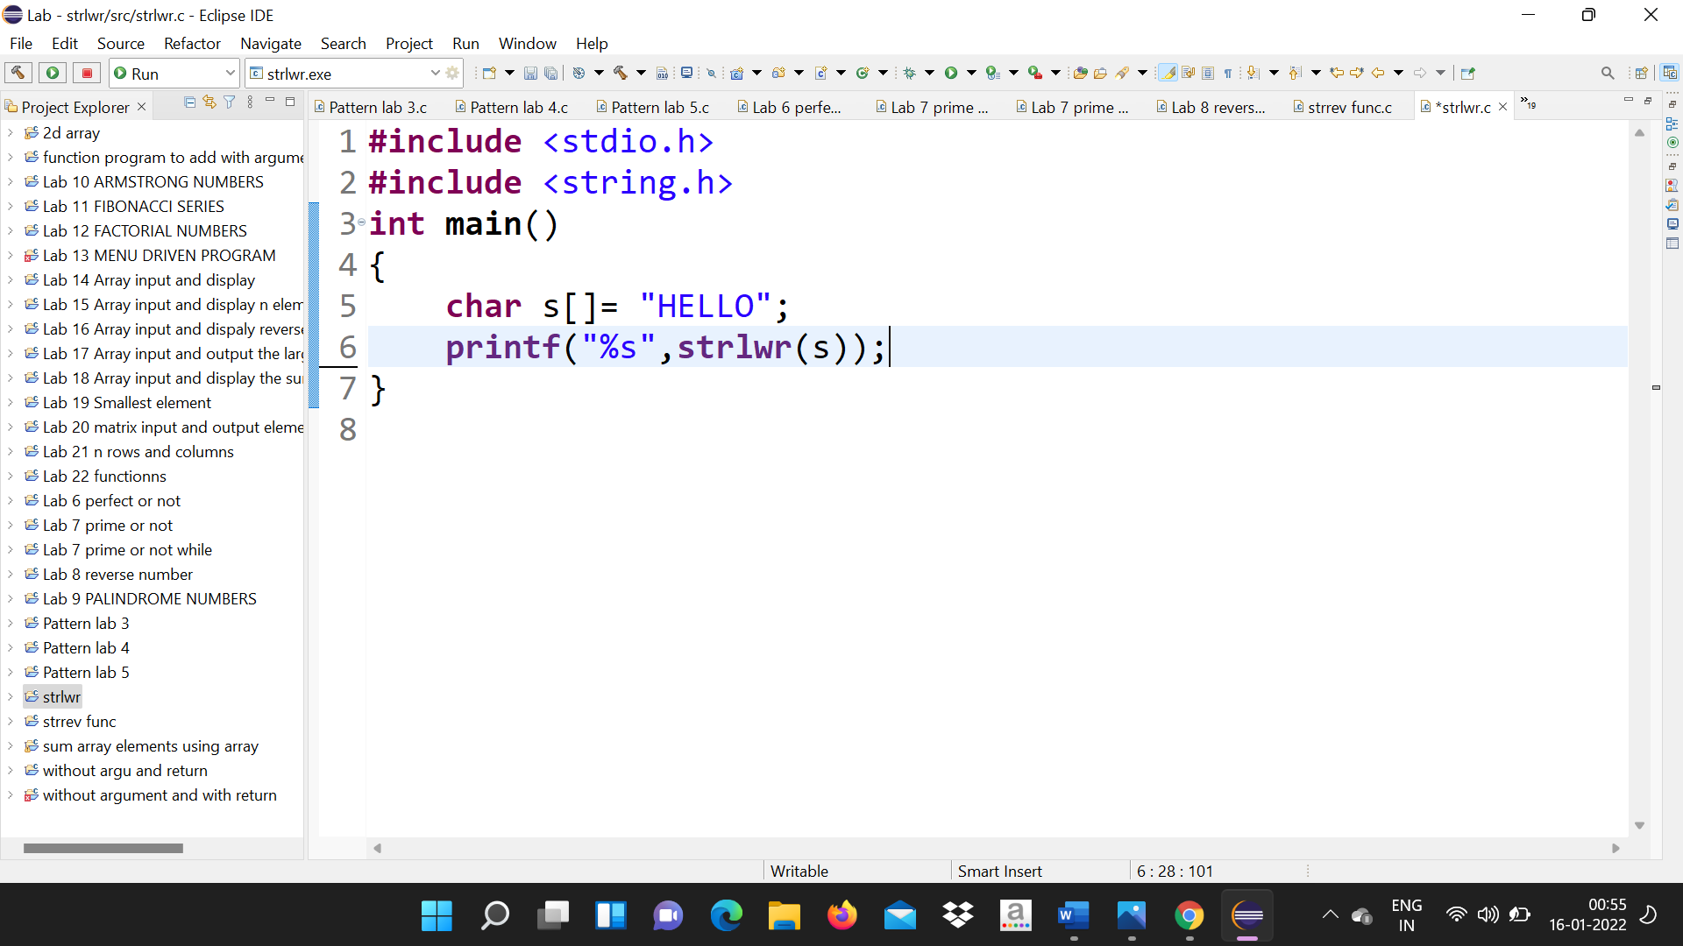

   o\p

   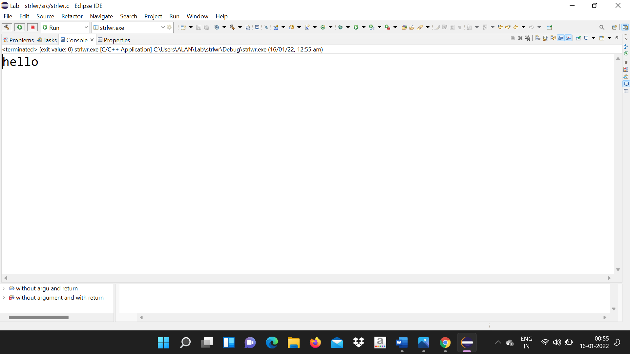

   7.strupr()

   ***It is used to convert the input to uppercase***

   *Eg:program to convert a string to upper case*.

   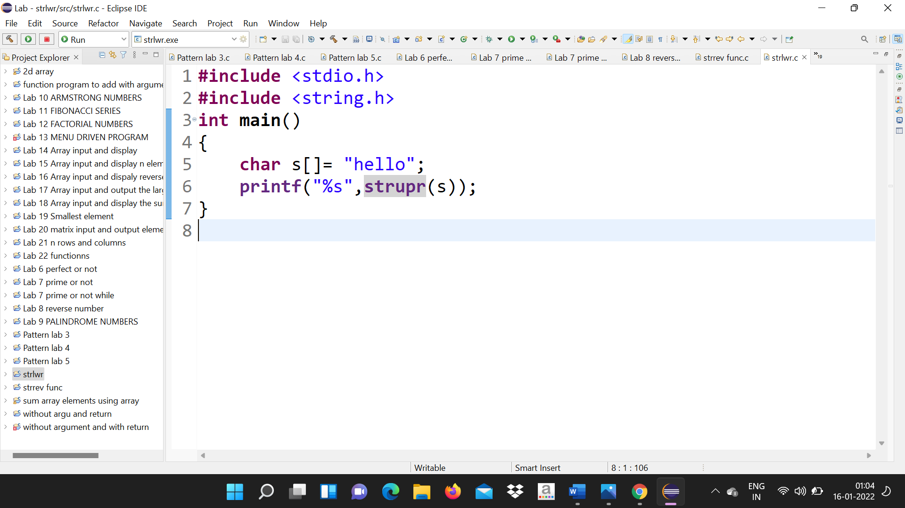

   o\p

   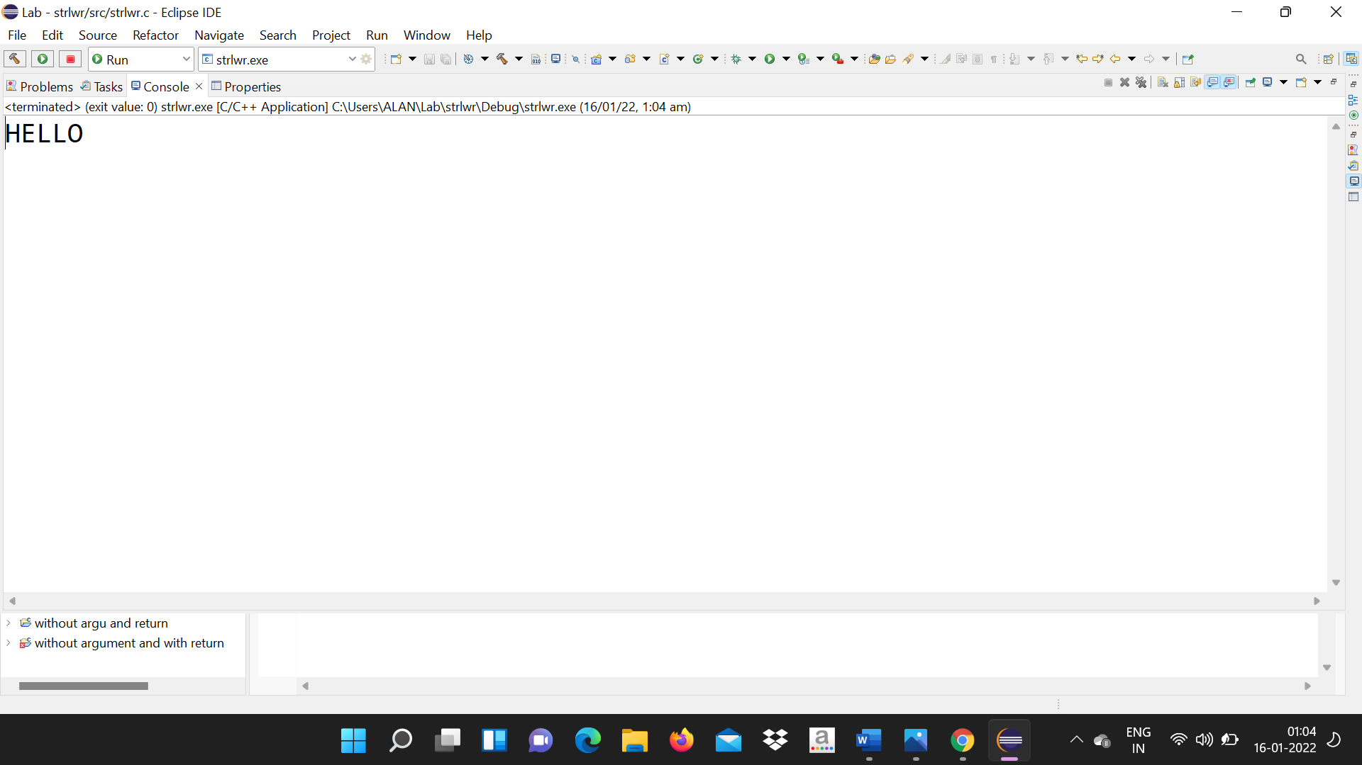

   **8.strncat().**

   ***It is used to concatenate n characters of string to another string.***

   *Eq:program to concatenate n characters of string to another*

   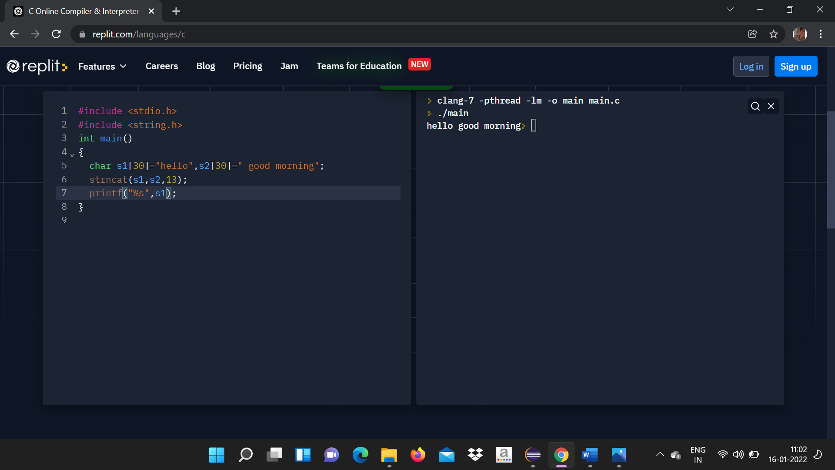

   o\p

   

   **9.strncpy().**

   ***It is used to copy n characters from a string to another.***

   *Eq:program to copy n characters from a string to another.*

   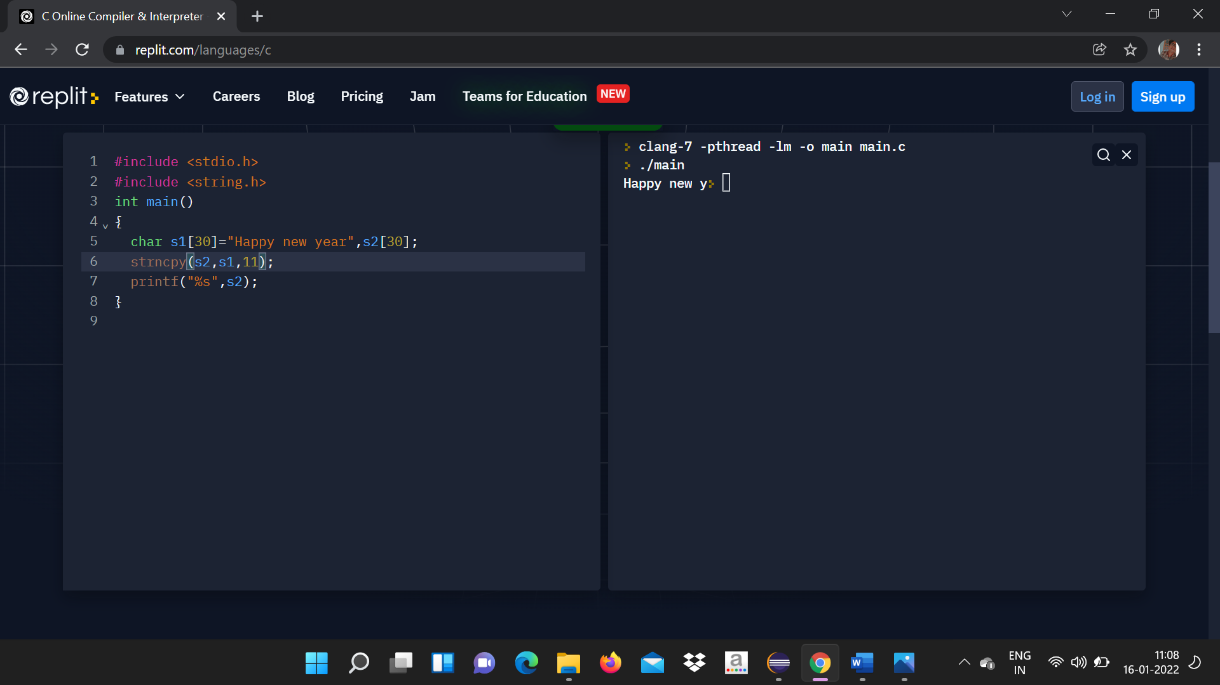

   o\p

   

   **10.strstr(str1,str2).**

   ***It returns pointer to first occurrence of str2 in str1****.*

   *Eq:program to return the occurrence of one string to another*

   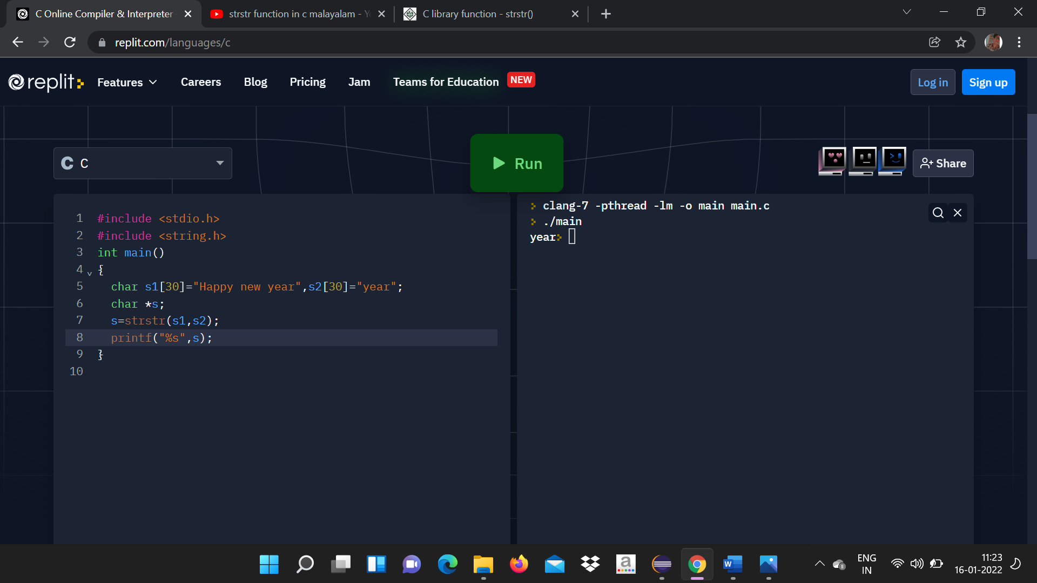

   o\p

   

   *END*